Usage Statistics for snydersstoughton.com
Summary Period: Last 12 Months
Generated 17-Nov-2008 01:33 EST

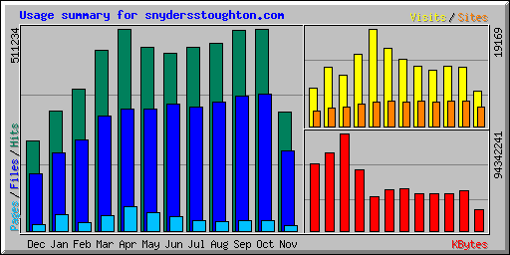
Summary by Month
Month | Daily Avg |  |  |  | Monthly Totals
Month | Hits | Files | Pages | Visits | Sites | KBytes | Visits | Pages | Files | Hits
Nov 2008 | 17658 | 11987 | 843 | 407 | 3722 | 20413523 | 6935 | 14338 | 203779 | 300186
Oct 2008 | 16491 | 11145 | 850 | 378 | 4913 | 38572479 | 11723 | 26365 | 345521 | 511234
Sep 2008 | 16940 | 11408 | 913 | 396 | 4927 | 36295908 | 11898 | 27419 | 342256 | 508218
Aug 2008 | 15324 | 10543 | 759 | 356 | 4874 | 36485561 | 11057 | 23551 | 326833 | 475048
Jul 2008 | 14976 | 10118 | 825 | 379 | 4961 | 36561538 | 11759 | 25592 | 313679 | 464268
Jun 2008 | 15001 | 10662 | 1247 | 438 | 4879 | 40571509 | 13164 | 37433 | 319874 | 450039
May 2008 | 15009 | 9954 | 1472 | 495 | 4994 | 39656455 | 15372 | 45648 | 308596 | 465293
Apr 2008 | 17032 | 10289 | 2027 | 638 | 4831 | 33410770 | 19169 | 60831 | 308677 | 510982
Mar 2008 | 14718 | 9412 | 1275 | 460 | 4358 | 58775996 | 14278 | 39543 | 291786 | 456284
Feb 2008 | 12368 | 7971 | 723 | 345 | 3739 | 94342241 | 10026 | 20982 | 231187 | 358699
Jan 2008 | 10124 | 6605 | 1389 | 389 | 3679 | 75359564 | 11688 | 41681 | 198167 | 303728
Dec 2007 | 7637 | 4859 | 514 | 247 | 2943 | 64538308 | 7436 | 15443 | 145773 | 229119
Totals |  |  |  |  |  | 574983852 | 144505 | 378826 | 3336128 | 5033098

Generated by Webalizer Version 2.01

